# Screen and Media Industry - Immersion activities and portfolio evidence

Name:_______________________

Date:________________________

Below are 2 activities to help demonstrate your VETRO Evidence (Industry and Portfolio).   
Please complete the required tasks to help in our application to apply for Certificate III in Screen and Media.

## Tinkercad – 3D Modelling **– Portfolio Evidence**

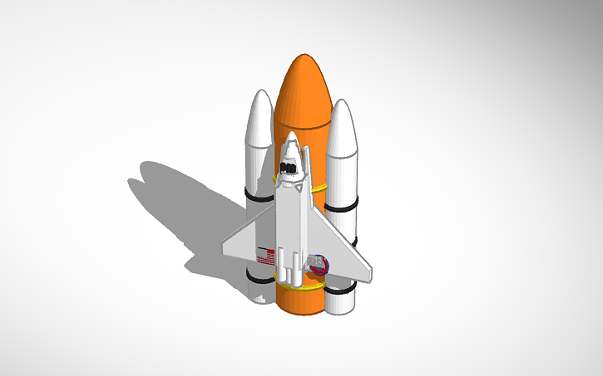Tinkercad a FREE to use 3D software that is run on your web browser   
(no need to install software) <https://www.tinkercad.com/>

**Step 1:** **make an account** with your email address.

**Step 2: Learn** how to use the basics of Tinkercad here: <https://www.youtube.com/watch?v=gOs6Mdj7y_4> (9 minutes)

**Challenge**, to make a 3D object, - suggestion: create your own design of a Rocketship.   
Or follow one of the provided tutorials <https://www.tinkercad.com/learn/designs>.   
Place your screen shots of your progress and final object below.

Take 2-3 screen shots of your **progress**

INSERT SCREENSHOTS

Take 2-3 screen shots of your **final** object

INSERT SCREENSHOTS

## 3D Modelling Reflection

What did you learn about Tinkercad/3D Modelling?

What did you learn about 3D modelling software?

## Podcasts Task **– Industry Immersion**

In order to demonstrate your industry evidence and also interest in the screen and media areas you are required to: **Listen to a total of 3 Podcasts, approx. 30mins - 1 hour each**

Instructions

* Below is a list of suggested podcasts, however you are able to find your own
* Podcasts can be listened to on a variety of devices (Phone, Chrome, Apple, Spotify, PC) so choose what works for you.
* Complete the questions below about the podcasts
* Submit the write up as part of your industry evidence (VETRO)

**VFX:**

<https://www.fxguide.com/thevfxshow/>

<https://www.fxguide.com/fxpodcasts/>

**Game:**

<https://uploadvr.com/podcast-the-vr-download/> (VR)

<https://shows.acast.com/whatculturegaming>

<https://elitegamedevelopers.com/podcast/>

<https://www.ign.com/watch/game-scoop>

**Animation:**

<https://terryibele.com/animation-industry-podcast/>

**Film:**

<https://nofilmschool.com/tags/podcasts>

**General:**

<https://www.screenaustralia.gov.au/screen-news/podcast>

<https://www.acmi.net.au/whats-on/inside-acmi-x-podcast/>

|  |  |
| --- | --- |
| *Podcast review 1* | |
| Listened to: | (add podcast name) |
| Episode and release date: | (add number and date) |
| Listened on: | (add date listened) |
| Length of podcast | (add in mins/hours) |
| About the podcast (approx. 1 paragraph in total) | |
| What was discussed? |  |
| What did you learn? (software, technologies) |  |

|  |  |
| --- | --- |
| *Podcast review 2* | |
| Listened to: | (add podcast name) |
| Episode and release date: | (add number and date) |
| Listened on: | (add date listened) |
| Length of podcast | (add in mins/hours) |
| About the podcast (approx. 1 paragraph in total) | |
| What was discussed? |  |
| What did you learn? (software, technologies) |  |

|  |  |
| --- | --- |
| *Podcast review 3* | |
| Listened to: | (add podcast name) |
| Episode and release date: | (add number and date) |
| Listened on: | (add date listened) |
| Length of podcast | (add in mins/hours) |
| About the podcast (approx. 1 paragraph in total) | |
| What was discussed? |  |
| What did you learn? (software, technologies) |  |